Milestone 1
Create UI Policy on Incident

Objective
Create a UI Policy on the ServiceNow Incident table to apply additional controls when the Incident Impact is High.

Activity 1 – Create UI Policy
- Log in to the ServiceNow instance with administrative or configuration access.
- Navigate to System UI → UI Policies.
- Click New to create a new UI Policy record.
- Enter the UI Policy details.
Field | Configuration
Name | High Impact Control
Table | Incident
Active | true
Condition | Impact is 1 – High
Reverse if false | true
UI Policy Action | Assignment group – Mandatory

Condition
- Field: Impact
- Operator: is
- Value: 1 – High
The condition ensures that the UI Policy is triggered only when the Incident Impact is set to High.
Reverse if false is enabled so that field changes applied by the policy are reverted when the condition is no longer true.

Expected Result
The High Impact Control UI Policy is saved and configured to make Assignment group mandatory when Impact is High.
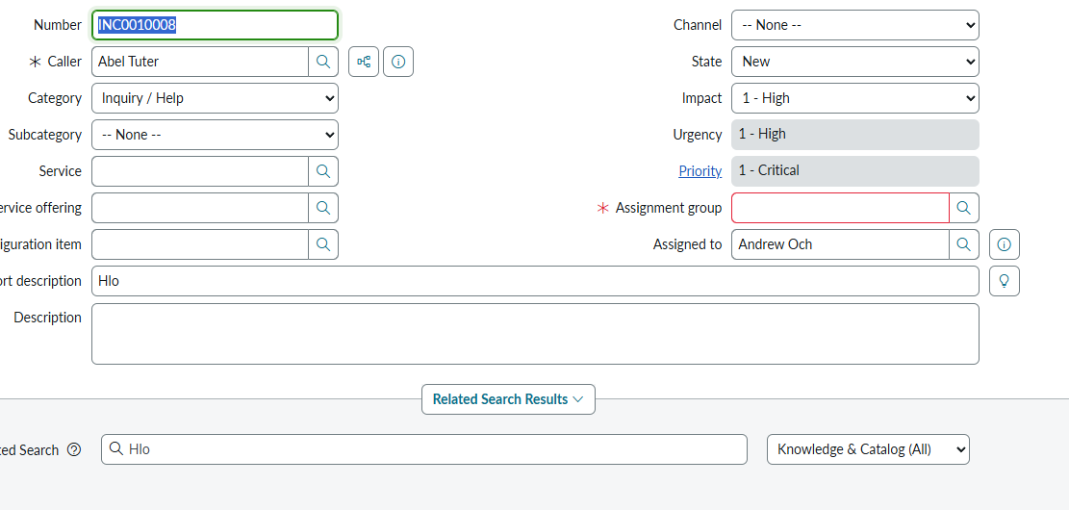
Use the relevant uploaded screenshot(s) showing the UI Policy configuration.

